Assignment-9
Design an application using Angular JS. e.g., Design registration (first name, last name, username, password) and login page using Angular JS.

✅ Overview
We will:
- Install necessary software
- Set up the project folder
- Create Registration and Login pages
- Handle form validation and simple authentication (mock)
- Run and test the AngularJS application

📦 Step 1: Install Required Software
1. Install Node.js and npm
AngularJS (1.x) doesn't require Node.js to run, but you need it for serving with http-server.
- Go to: https://nodejs.org/
- Download and install LTS version (e.g., Node.js v18.x.x or latest LTS)
- Verify installation:
- node -v
- npm -v

2. Install a Simple Web Server
We'll use http-server to serve static AngularJS files.
npm install -g http-server
Verify:
http-server -v

3. Install a Code Editor
Use Visual Studio Code (VS Code)
- Download: https://code.visualstudio.com/
- Install and open the editor.

📁 Step 2: Project Setup
- Create a project folder:
- mkdir angularjs-auth-app
- cd angularjs-auth-app
- Inside the folder, create these files:
angularjs-auth-app/
│
├── index.html
├── app.js
├── login.html
├── register.html
├── style.css

🧠 Step 3: Code Explanation and Development
🔸 index.html
This is your main file.
<!DOCTYPE html>
<html ng-app="authApp">
<head>
<title>AngularJS Auth App</title>
<script src="https://ajax.googleapis.com/ajax/libs/angularjs/1.8.3/angular.min.js"></script>
<script src="app.js"></script>
<link rel="stylesheet" href="style.css">
</head>
<body>
<div ng-view></div>
</body>
</html>

🔸 app.js
Defines AngularJS module, routes, and controller.
var app = angular.module("authApp", ["ngRoute"]);

app.config(function($routeProvider) {
$routeProvider
.when("/register", {
templateUrl: "register.html",
controller: "RegisterController"
})
.when("/login", {
templateUrl: "login.html",
controller: "LoginController"
})
.otherwise({
redirectTo: "/register"
});
});
app.controller("RegisterController", function($scope) {
$scope.user = {};
$scope.register = function() {
if ($scope.user.password === $scope.user.confirmPassword) {
localStorage.setItem("userData", JSON.stringify($scope.user));
alert("Registration successful! Please login.");
window.location.href = "#!/login";
} else {
alert("Passwords do not match!");
}
};
});
app.controller("LoginController", function($scope) {
$scope.loginData = {};
$scope.login = function() {
var user = JSON.parse(localStorage.getItem("userData"));
if (
user &&
$scope.loginData.username === user.username &&
$scope.loginData.password === user.password
) {
alert("Login successful!");
} else {
alert("Invalid username or password.");
}
};
});

🔸 register.html
<h2>Register</h2>
<form ng-submit="register()">
<label>First Name:</label>
<input type="text" ng-model="user.firstName" required><br><br>

<label>Last Name:</label>
<input type="text" ng-model="user.lastName" required><br><br>

<label>Username:</label>
<input type="text" ng-model="user.username" required><br><br>

<label>Password:</label>
<input type="password" ng-model="user.password" required><br><br>

<label>Confirm Password:</label>
<input type="password" ng-model="user.confirmPassword" required><br><br>

<button type="submit">Register</button>
<a href="#!/login">Already have an account? Login</a>
</form>

🔸 login.html
<h2>Login</h2>
<form ng-submit="login()">
<label>Username:</label>
<input type="text" ng-model="loginData.username" required><br><br>

<label>Password:</label>
<input type="password" ng-model="loginData.password" required><br><br>

<button type="submit">Login</button>
<a href="#!/register">Don’t have an account? Register</a>
</form>

🔸 style.css (Optional Styling)
body {
font-family: Arial;
margin: 30px;
}
input {
padding: 5px;
margin: 5px 0;
}
button {
padding: 6px 12px;
margin-top: 10px;
}
a {
margin-left: 10px;
}

🚀 Step 4: Run the Application
In your terminal or command prompt:
- Navigate to project folder:
- cd path/to/angularjs-auth-app
- Start the HTTP server:
- http-server
- Open your browser and go to:
- http://localhost:8080
If the page doesn’t load correctly, go to http://localhost:8080/#/register

✅ Summary of What You Did
Step | Description
1 | Installed Node.js and http-server
2 | Created AngularJS files
3 | Wrote controllers and views
4 | Used localStorage for mock registration/login
5 | Ran the app in browser

📝 Notes
- This is a mock system — not secure for production!
- No backend; user data is stored in localStorage

COMMAND PROMPT INPUTS:
Microsoft Windows [Version 10.0.26100.3775]
(c) Microsoft Corporation. All rights reserved.
C:\Users\rashm>node -v
v22.14.0
C:\Users\rashm>npm -v
10.9.2
C:\Users\rashm>npm install -g http-server
added 48 packages in 7s
15 packages are looking for funding
run `npm fund` for details
npm notice
npm notice New major version of npm available! 10.9.2 -> 11.3.0
npm notice Changelog: https://github.com/npm/cli/releases/tag/v11.3.0
npm notice To update run: npm install -g npm@11.3.0
npm notice
C:\Users\rashm>http-server -v
v14.1.1
C:\Users\rashm>mkdir angularjs-auth-app
C:\Users\rashm>cd angularjs-auth-app
C:\Users\rashm\angularjs-auth-app>Notepad index.html
C:\Users\rashm\angularjs-auth-app>Notepad app.js
C:\Users\rashm\angularjs-auth-app>Notepad login.html
C:\Users\rashm\angularjs-auth-app>Notepad register.html
C:\Users\rashm\angularjs-auth-app>Notepad style.css
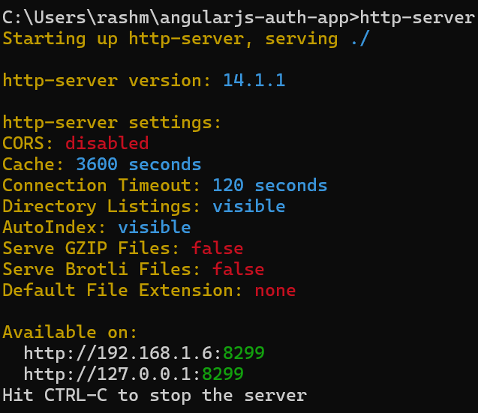
Open web browser: http://127.0.0.1:8082/#/register
OUTPUT:

